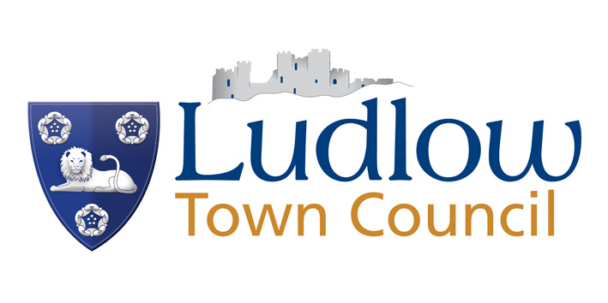

A CIVIC AWARD/YOUNG PERSONS’ CIVIC AWARD
NOMINATION FORM 2024

Name of person/Group being nominated:

Address:

Email Address: _______________________________ Telephone No. _______________________

Please ensure that either the email address or telephone number is provided as successful nominees will be contacted directly and invited to accept their award.
Award being nominated for (please tick ONE box below):
□ Over 18 - Civic Award
□ Under 18 - Young Persons’ Civic Award
□ Community Group –Civic Award

Reason for nomination (please tick all boxes below which apply):
□ Material contribution to the advancement, well-being and welfare of the people of Ludlow.
□ Demonstrated outstanding citizenship
□ Carried out unpaid work in the community for some time
□ Through their endeavours put Ludlow on the map: or
□ Through their contribution made Ludlow a better place to live
□ Voluntary community work during the Covid-19 pandemic

I certify that the details given are correct, that I have not been influenced or canvassed in any way and that the person nominated has no knowledge of the present application and understand that all matters relating to the nomination are confidential and that should the present nomination fail, it may be re-submitted after next May.

PROPOSER:

Name: Signature:
Address: Tel:

Email Address: ______________________________________

SECONDER:

Name: Signature:
Address: Tel:

Email Address:______________________________________
The reason for the nomination is detailed below:

Please return to: Gina Wilding Town Clerk, Ludlow Town Council, The Guildhall, Mill Street, Ludlow SY8 1AZ Tel: 01584 871970 townclerk@ludlow.gov.uk by 12 noon Tuesday 30th April 2024

PRIVACY NOTICE

Ludlow Town Council collects and manages personal data under the Data Protection Act 1998 and the General Data Protection Regulations 2018.

Your information will be lawfully processed by the Council and will not be shared with any third parties without consent.

To find out more about our privacy arrangements, please access the Council’s website www.ludlow.gov.uk where our full Privacy Notice and Privacy Policy can be viewed.

